**Window and GUI Management**

* **Functions:**
  + CreateWindow()
  + CreateWindowEx()
  + DestroyWindow()
  + ShowWindow()
  + UpdateWindow()
  + DefWindowProc()
  + GetMessage()
  + DispatchMessage()
  + TranslateMessage()
  + PostMessage()
  + SendMessage()
  + RegisterClass()
  + RegisterClassEx()
* **Structures:**
  + WNDCLASS
  + WNDCLASSEX
  + MSG
  + RECT
  + PAINTSTRUCT

**Struct contents**

WNDCLASS – Window Class Structure

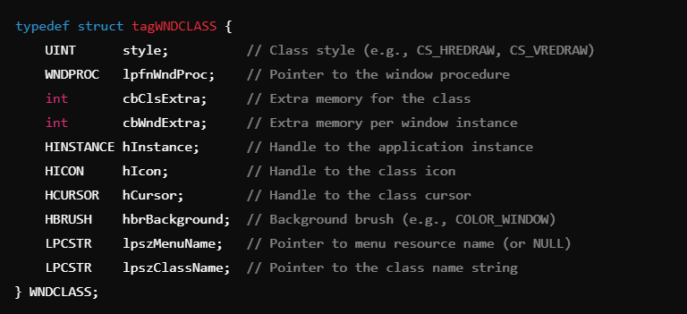

**Explanation of Fields:**

* **style** – Specifies class behavior (e.g., CS_HREDRAW for redrawing on horizontal resize).
* **lpfnWndProc** – Function pointer to the window procedure.
* **cbClsExtra** – Number of extra bytes allocated for the class.
* **cbWndExtra** – Number of extra bytes allocated per window instance.
* **hInstance** – Handle to the application’s instance.
* **hIcon** – Icon for the window.
* **hCursor** – Cursor for the window.
* **hbrBackground** – Brush for the background (e.g., COLOR_WINDOW).
* **lpszMenuName** – Name of the menu resource (or NULL if none).
* **lpszClassName** – Name of the class used in CreateWindowEx.

WNDCLASSEX – Extended Window Class Structure

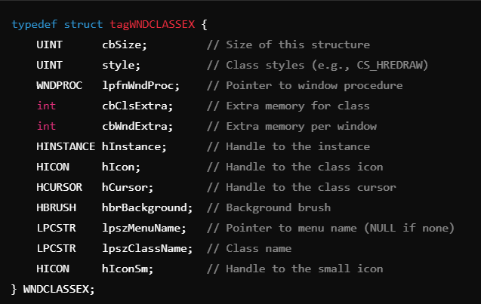

**Differences from WNDCLASS:**

* **cbSize –** Specifies the size of this structure.
* **hIconSm –** A small version of the window icon, used in the taskbar or window corners.

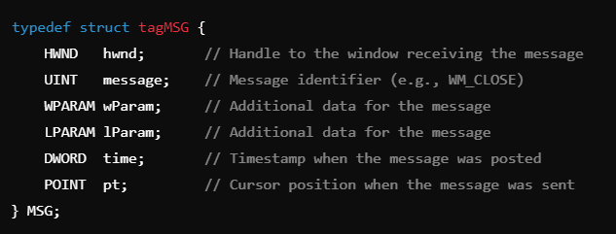MSG – Message Structure

**Explanation of Fields:**

* **hwnd** – Handle to the window receiving the message.
* **message** – The message type (e.g., WM_CLOSE, WM_KEYDOWN).
* **wParam** – Additional message-specific information.
* **lParam** – Additional message-specific information.
* **time** – Time when the message was posted.
* **pt** – POINT structure representing the cursor position.

RECT – Rectangle Structure

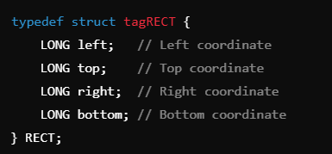

**Explanation of Fields:**

* **left** – X-coordinate of the left edge.
* **top** – Y-coordinate of the top edge.
* **right** – X-coordinate of the right edge.
* **bottom** – Y-coordinate of the bottom edge.

Example:



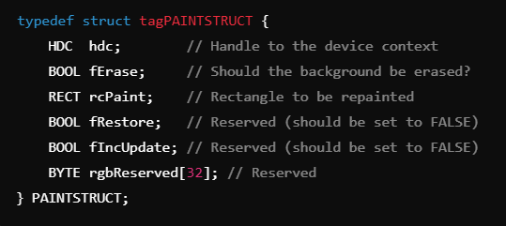PAINTSTRUCT – Painting Structure

**Explanation of Fields:**

* **hdc** – Handle to the device context for drawing.
* **fErase** – If TRUE, erase the background.
* **rcPaint** – RECT defining the invalidated area.
* **fRestore** – Reserved (usually FALSE).
* **fIncUpdate** – Reserved (usually FALSE).
* **rgbReserved[32]** – Reserved bytes.

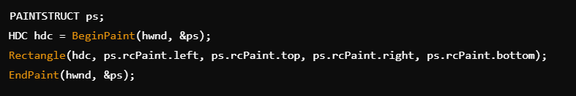Example:

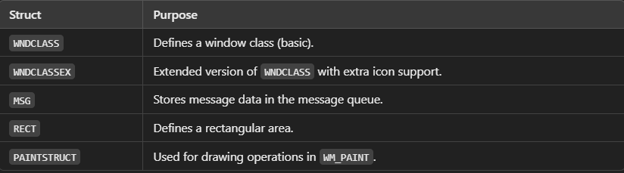**Summary:**

**Functions**